P210/3
History
(EUROPEAN HISTORY)
Paper 3
MAY-JUNE-2023
3 hours

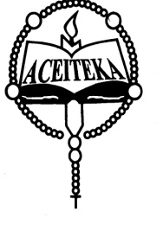
ACEITEKA JOINT MOCK EXAMINATIONS 2023
UGANDA ADVANCED CERTIFICATE OF EDUCATION
HISTORY
(EUROPEAN HISTORY 1789 – 1970)
3 HOURS

Instructions:
Answer FOUR questions only.
All questions carry equal marks
Any additional questions attempted will not be marked.

- Account for European hostility against France in the period 1792 to 1814
(25 marks)
- “The violation of the 1814 constitutional charter was primary responsible for the collapse of the restored Bourbon Monarchy in France in 1830” Discuss.
(25 marks)
- How was Prince Metternich able to dominate Europe in the period of 1815 to 1845? (25 marks)
- Explain the process of German unification between 1850 and 1871.
(25 marks)
- Examine the causes and consequences the Greek war of independence.
(25 marks)
- To what extent was Serbia responsible for the 1914 – 1918 World catastrophe? (25 marks)
- How did the Versailles peace treaty of 1919 undermine European peace between 1919 and 1939? (25 marks)
- Account for the survival of Fascism in Italy up to 1944 (25 marks)

- Assess the role of Adolph Hitler in the outbreak of World War II.
(25 marks)
- How successful was the United Nations Organization up to 1970?

END

